Overview
This project implements an automated backend infrastructure for real-time stock market analytics. It handles the ingestion, validation, and feature enrichment of 60+ Indian stock tickers to support downstream Machine Learning (ML) operations without any manual intervention.
1. Architecture Overview:
Yahoo Finance
(Data Source)

Data Pipeline
-- Fetch Data
-- Clean Data
-- Add Features
(ETL Process)

Supabase DB
PostgreSQL
(Data Storage)

FastAPI
-- ML APIs
-- Dashboard
(API Layer)

2. Tech Stack:
- python
- FastAPI
- Supabase
- pandas
- yfinance
- numpy
- pyarrow
- uvicorn
- python-dotenv
Flow Diagram:
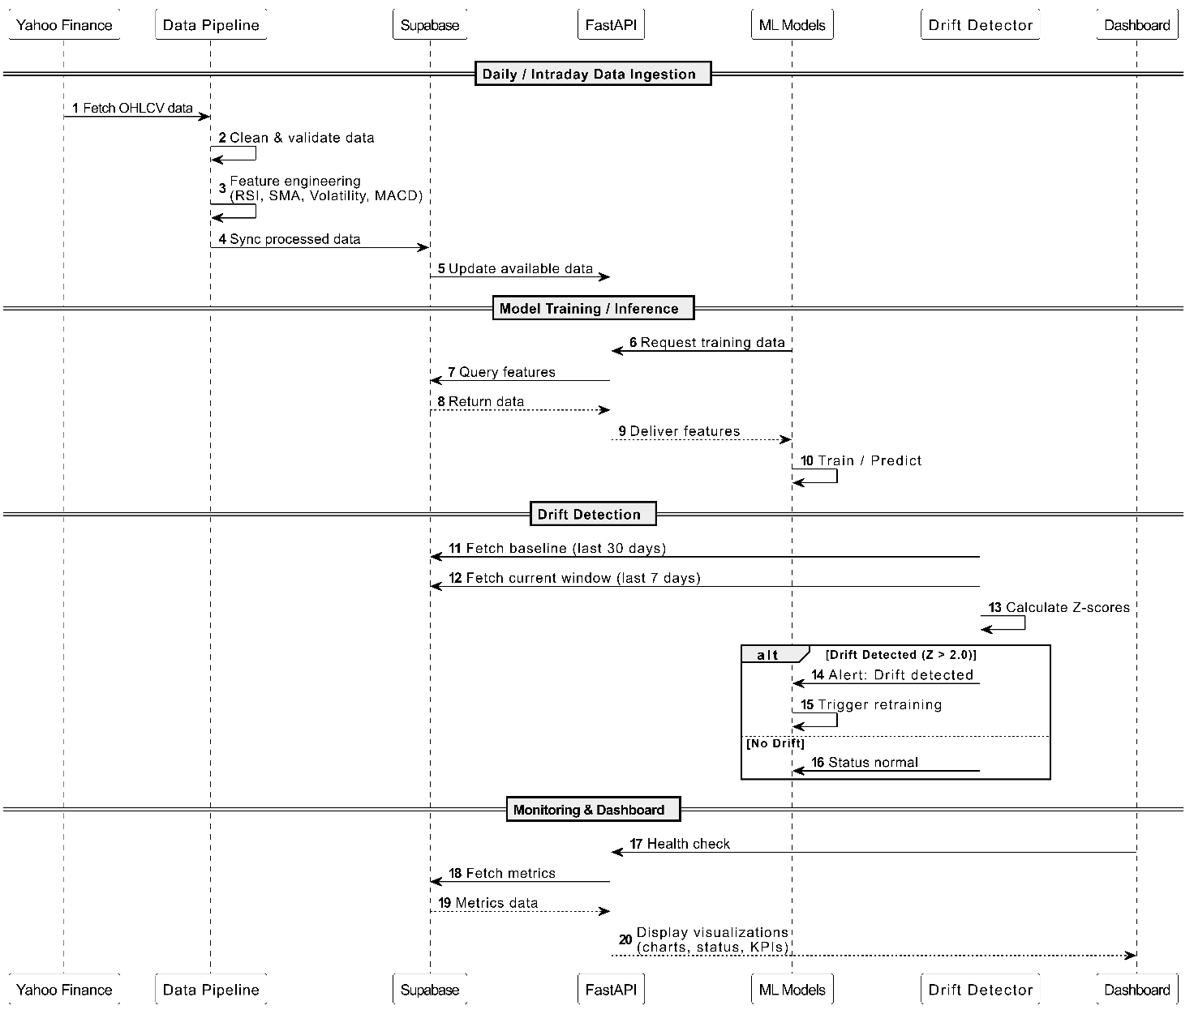
3. Technical Architecture
The system follows a Medallion Architecture pattern to ensure data quality and lineage:
- Bronze Layer (Raw): Immutable ingestion of OHLCV data from Yahoo Finance.
- Silver Layer (Cleaned): Application of business rules, OHLC consistency checks, and outlier detection.
- Gold Layer (Enriched): Dynamic feature engineering (RSI, SMA, MACD) stored for model consumption.
4. Techinal Indicators Added for ML model:
- Daily Return : Measures day-to-day price movement and is a foundational feature for return-based prediction models.
- RSI (14-period) : Indicates momentum strength and potential reversal zones based on recent gains and losses.
- Simple Moving Averages (SMA 20, SMA 50) : Smooth price fluctuations to reveal underlying trends and act as dynamic support/resistance levels.
- Rolling Volatility (20) : Represents market instability and helps ML models adapt to changing risk regimes.
- MACD : Combines trend-following and momentum indicators to detect buy/sell crossover signals.
- Volume Moving Average : Helps validate price action by analyzing participation strength in the market.
5. Data Modeling (PostgreSQL)
Data is persisted in a Supabase PostgreSQL database using a time-series optimized schema.
- Primary Table: stock_features
- Keys: Composite Primary Key on (ticker, date).
- Indexes: B-Tree indexing on date and ticker for high-performance retrieval.
6. ETL & Orchestration Logic
- Incremental Loading: The pipeline checks the database for existing records and only fetches missing date ranges.
- Parallel Processing: Uses ThreadPoolExecutor to process multiple tickers concurrently, significantly reducing execution time.
- Dual Persistence: Data is stored locally as Apache Parquet (for speed) and in the Cloud (for accessibility).
7. Data Quality & MLOps Governance
- Drift Detection: Implements Kolmogorov-Smirnov (KS) tests to monitor feature distribution shifts.
- Automated Alerts: If data drift is detected (p-value < 0.05), the system logs an alert for model retraining.

